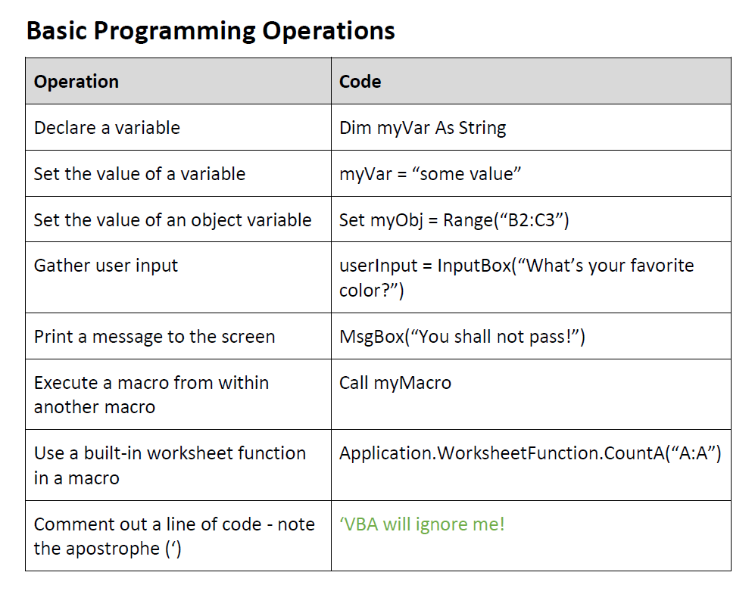

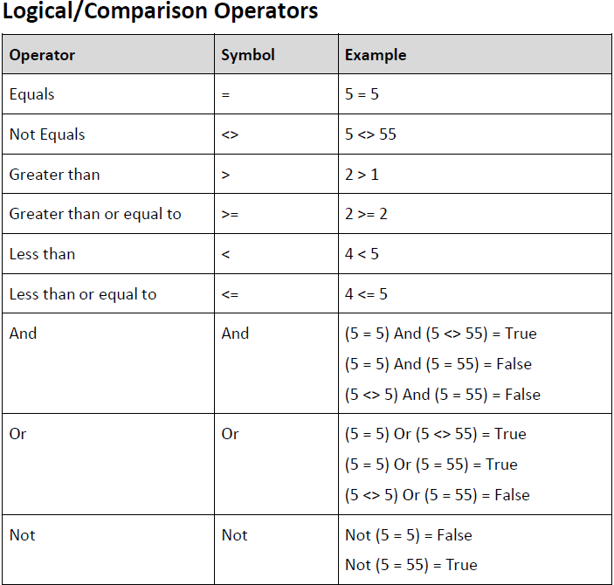

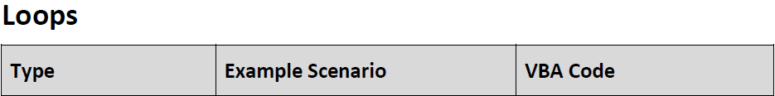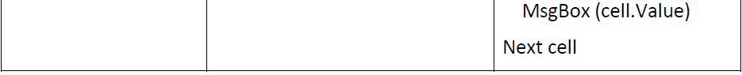

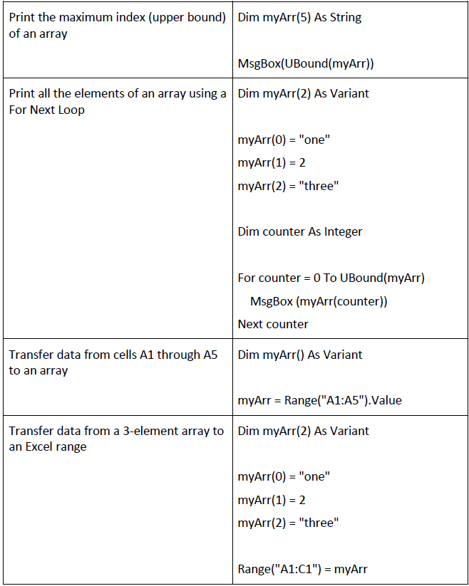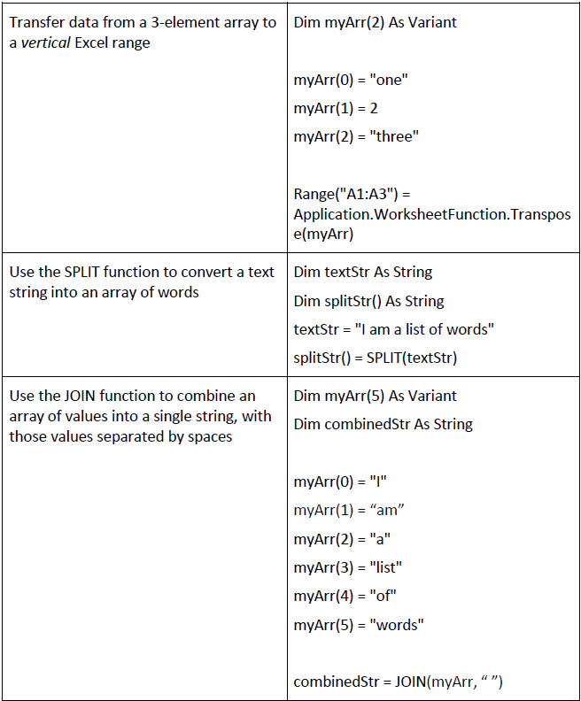

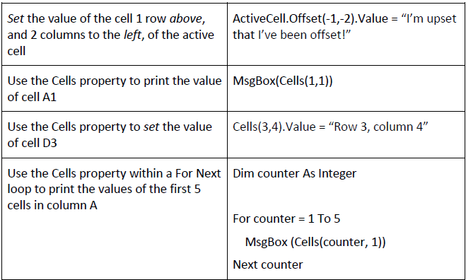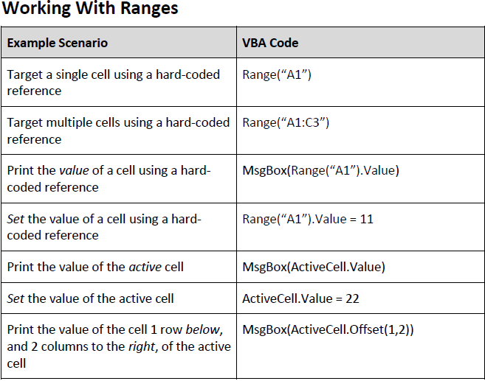

Excerpted from the VBA Cheat Sheet by ZeroToMastery (https://zerotomastery.io/cheatsheets/vba-cheat-sheet/)